### Coins And Triangle

### Read problems statements in [Mandarin Chinese](https://www.codechef.com/download/translated/LTIME35/mandarin/TRICOIN.pdf" \t "https://www.codechef.com/problems/_blank) , [Russian](https://www.codechef.com/download/translated/LTIME35/russian/TRICOIN.pdf" \t "https://www.codechef.com/problems/_blank) and [Vietnamese](https://www.codechef.com/download/translated/LTIME35/vietnamese/TRICOIN.pdf" \t "https://www.codechef.com/problems/_blank) as well.

Chef belongs to a very rich family which owns many gold mines. Today, he brought **N** gold coins and decided to form a triangle using these coins. Isn't it strange?

Chef has a unusual way of forming a triangle using gold coins, which is described as follows:

* He puts **1** coin in the **1st** row.
* then puts **2** coins in the **2nd** row.
* then puts **3** coins in the **3rd** row.
* and so on as shown in the given figure.

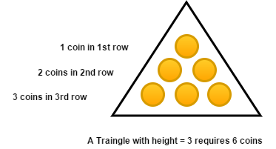

Chef is interested in forming a triangle with maximum possible height using at most **N** coins. Can you tell him the maximum possible height of the triangle?

### Input

The first line of input contains a single integer **T** denoting the number of test cases.

The first and the only line of each test case contains an integer **N** denoting the number of gold coins Chef has.

### Output

For each test case, output a single line containing an integer corresponding to the maximum possible height of the triangle that Chef can get.

### Constraints

* **1 ≤ T ≤ 100**
* **1 ≤ N ≤ 109**

### Subtasks

* Subtask 1 (48 points) : **1 ≤ N ≤ 105**
* Subtask 2 (52 points) : **1 ≤ N ≤ 109**

### Sample 1:

Input

Output

3

3

5

7

2

2

3

### Explanation:

**Test 1:** Chef can't form a triangle with height > 2 as it requires atleast 6 gold coins. **Test 2:** Chef can't form a triangle with height > 2 as it requires atleast 6 gold coins. **Test 3:** Chef can't form a triangle with height > 3 as it requires atleast 10 gold coins.

More Info

Time limit1.5 secs

Memory limit1.5 GB

Source Limit50000 Bytes